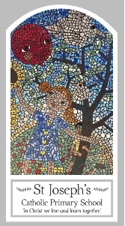
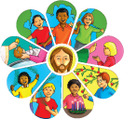
Early Years
Knowledge Organiser
Baptism/Confirmation – Belonging
Topic 2: Welcome
Key Words
Word | Definition
Welcome | To be pleased about and encourage or support something.
Welcomed | To feel like you belong somewhere.
Belong | To be in the right place.
School | A place where you receive an education.
Class | A group or team of people in a school.
Baptism | A Christian ceremony in which a person has water poured on their head to be welcomed into the Christian community.
Baptise | To make someone officially a member of the Christian Church in a service of Baptism.
Water | A clear liquid without colour or taste.
Candle | A stick shaped piece of wax with a wick piece of string in the middle of it.
In the name of … | Making the sign of the cross.
Priest | A person, usually a man, who has been trained to perform religious duties in the Christian Church,
White garment | A dress or clothes that is white.
Godparents | People who are selected to look after the spiritual wellbeing of a child.
Font | A large container of water inside a church that Holy water.
Scripture
Colossians 3:12

Big Question
Why Is welcome important?
My first thoughts:

What will I learn?
- To begin to talk about their own experiences and feelings of being welcomed.
- To begin to say what they wonder about how they can make others feel welcome.
- To begin to recognise some religious signs and symbols used in baptism. Some children will begin
- To use some religious words and phrases from the Rite of Baptism.

