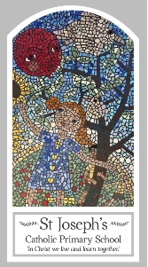
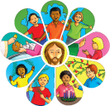
Early Years
Knowledge Organiser
Domestic Church – Family
Topic 1: Myself
Key Words
Word | Definition
myself | A term to describe yourself.
name | A word a person or animal is known as.
Christian | A person who believes in God.
First name | The name that comes first.
Family name | A persons surname e.g. Miss Jenkinson.
Class name | The name your class is known as e.g. EYFS, Y1, Y2…
precious | Something that is special.
parent | The person who is responsible for you until you are 18
God | A special spirit that we believe in.
love | The feeling you get for special people.
Loving parent | When your mum or dad sows they love you.
prayer | Special words you say in your head or out loud when you want to talk to God.
Scripture
Isaiah 43: 1-2 God’s Story 1
Psalm 131 God’s Story 1

Big Question
Why am I precious?
My first thoughts:

What will I learn?
- To be able to talk about their own feelings, experiences of being known and called by name.
- To be able to recognise some phrases from the Psalms which tell about God’s love for them.

