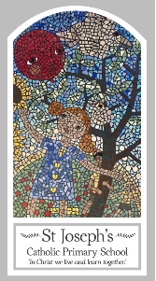
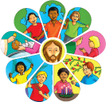
Early Years
Knowledge Organiser
Other Religions
Special Days/Ritual Objects – Hanukkah

Key Words
Word | Definition
Special days | A day that is celebrated.
Jewish | A person who believes in the practice of Judaism.
Hanukkah | An eight-day Jewish festival and holiday in December (or sometimes starting in late November) when Jews remember the occasion when the temple in Jerusalem was dedicated.
lamp | A device that uses electricity, oil or gas to produce light.
light | The energy from the sun, a lamp, etc. that makes it possible to see things.
Reception: Menorah | A traditional Jewish object to hold seven or nine candles.

Topic
Hanukkah(Chanukah)
The feast of lights
My first thoughts:

Look
There are special days

Discover
Hanukkah. The story of the oil lamp in the Temple

Respect
God cares for his people

