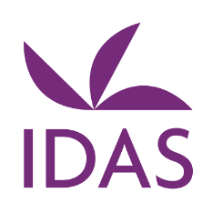 Live Online Training courses
All training sessions will be via ZOOM – Links to the training to be sent upon registration
Participants will be limited to 25 trainees per session
To register, please do so via https://courses.idas.org.uk
For any queries please do contact the IDAS Training Organiser at ……….

April 2021
*Domestic Abuse Signs, Indicators and Referral pathways (beginners)
28th April | 10:00am – 12:00pm

May 2021

Domestic Abuse, Risk Assessment and MARAC
5th May | 10:00am – 12:00pm

Male Victims and Domestic Abuse
11th May| 10:00am – 12:00pm

Supporting People with Disabilities and Domestic Abuse
25th May| 10:00am – 12:00pm

PLEASE NOTE: Some of the training above is delivered as blended training, Therefore, you may receive resources and pre-course material ahead of the training session. Following completion of the session, further resources will be sent out to enhance learning.

* PLEASE ALSO NOTE: It is advisable to complete “Domestic Abuse signs, indicators and referral Pathways” BEFORE you complete “Domestic abuse, risk assessment and MARAC” as the second course builds upon the first course.

