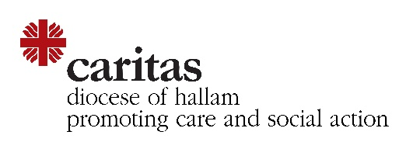
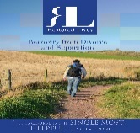
ZOOM
Restored Lives
Six Wednesday evenings
Commencing February 3rd 2021
6pm – 8pm
Cost: £20

……………………………………………………………………………………………………………………………………………….
BOOKING FORM
First Name:
Surname:
Address:
Email:
Telephone:
Are you separated/divorced (please circle). If so, for how long?
Do you have children? What are their ages?
How did you find out about the course?
I enclose a payment of £20
By bank transfer please reference Restored Lives
Account name: Diocese of Hallam Caring Services
Bank: HSBC Carmel House 49-63 Fargate Sheffield S1 2HD
Account no: 41842986
Sort Code: 40 41 07
Or by cheque
Made payable to Hallam Caring Services

Please return by email to
stym@hallam-diocese.com
0114 2566407

