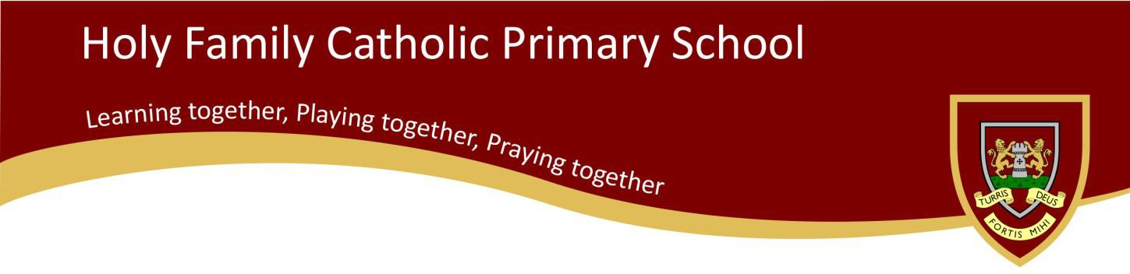

**Class Teacher**

**Holy Family Catholic Primary School** Kirton Lane, Stainforth, Doncaster DN7 5BL

**Tel:** 01302 841283

**Web:** [www.holyfamily.doncaster.sch.uk](http://www.holyfamily.doncaster.sch.uk/)

**Email:** [sarah.cashmore@fancisxavier.co.uk](mailto:admin@holyfamilyschool.co.uk)

**Executive Headteacher**: Mrs B Nesbit

**Chair of Governors:** Miss A Dews

**Acting Head of School:** Mr J Ascroft

**Come join our amazing team!**

**We are looking for someone who has a passion for learning and be a practitioner that others can be inspired by!**

Holy Family Primary School is a Catholic Voluntary Academy located in the east of Doncaster. It is a vibrant and aspirational school with a proud and visible Catholic ethos underpinning a positive approach to both learning and behaviour.

**The successful candidate will:**

* Be an excellent teacher who can support high quality learning, teaching and assessment;
* support fully our Catholic ethos, vision and values;
* demonstrate a passion for teaching and be a practitioner that others can be inspired by;
* possess excellent communication and interpersonal skills with parents and deploy staff effectively;
* Has excellent subject knowledge in all subjects
* be creative in inspiring, nurturing and motivating our children and staff;
* have high expectations regarding pupils’ progress, achievement and behaviour;
* Prepared to be hardworking and well organised!
* be committed to achieving the best outcome for every child;
* ensure consistency of practice, standards and expectations;
* be committed to their own continuing professional development;

be prepared to engage actively and fully with the wider life of school and the development of others;

**We can offer:**

* An exciting opportunity to work in a school that is striving to be the best it can be
* A commitment to you and your professional development
* A commitment to fully to supporting all staff in order to drive and sustain school improvement
* Wonderful and well behaved children
* A well -resourced school
* Leadership opportunities
* A hardworking team that works together for the best outcomes for pupils
* Opportunities to engage with colleagues in partner schools
* A warm and welcoming environment
* Children who are resilient, well-behaved and love to learn!

Application packs are available on request. The CES application form must be completed. Please request one via the email below.

If you would like an application pack or have any questions, please contact **Sarah Cashmore (sarah.cashmore@francisxavier.co.uk)**

**This is a full-time permanent position subject to successful completion of a probationary period**

**Required for September 2021 or sooner if possible**

**Main Pay Scale** (NQTs welcome to apply)

**Closing Date:** Friday 8th January 2021, 12 noon

**Shortlisting:** Monday 11th January 2021

**Interviews:** Thursday 14th January 2021

The Governing Body is fully committed to safeguarding and to promoting the safety and welfare of all our young people.

There is a firm expectation that all staff will be accountable in sharing this commitment actively. The post is subject to an enhanced DBS check.

**Our Story**

* An Ofsted rating of ‘Good’ (2017)
* Strong results in statutory assessments over the past three years
* Massive investment to improve our school buildings and infrastructure in the last three years
* Active and supportive Governors
* Excellent links with parents and carers
* A close partnership with our parish and the Diocese of Hallam
* Aspirational vision
* A wonderful team of staff who work together
* A school that supports developing leaders