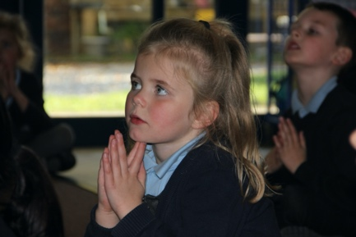
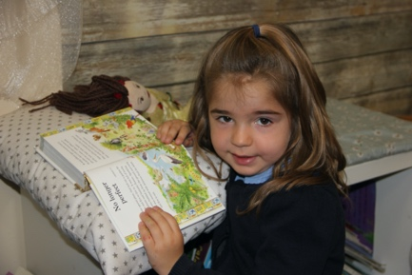
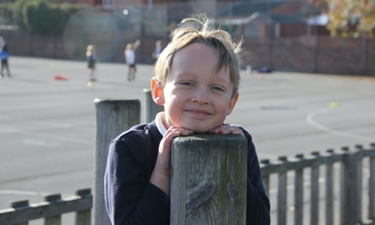
St Mary’s Catholic Primary School
Let Your Light Shine

Year 4 Teacher Maternity Cover Part Time 0.5

We are looking for a part time Year 4 teacher to cover a maternity leave with immediate start. The post is likely to be for 2 terms. St Mary’s is a two form entry Catholic school with an exciting drive for continued improvement, an innovative curriculum and wonderful teachers and children.

We are looking for someone who has:
- Experience of Key Stage 2 teaching
- A track record of high standards in teaching, learning and behaviour management
- The ability to reflect and seek to improve their practice by engaging with CPD and professional feedback
- Good teamwork skills
- The ability to work flexibly and adapt to changes
- A positive outlook and is solution focused
- The ability to engage with parents and develop positive relationships with pupils and staff
- A commitment to the school’s Catholic ethos
We will offer you:
- An enthusiastic, supportive and forward thinking team
- Innovative CPD opportunities
- Friendly, motivated, committed staff
- Supportive governors who are committed to our journey to excellence
- The chance to work with parents who are supportive of our school values and ethos
- Happy, engaged and well-motivated children (Behaviour, Personal Development and Attitudes Outstanding Ofsted Dec 2018)

Headteacher: Mrs N. Brown
Chair of Governors: Mr I. Findlay
Main pay scale
Start date: immediate
Contract type: maternity part time
Closing date: Friday 20th November 12pm
Interviews: Friday 27th November

Our school is committed to the safeguarding of children; all appointments are subject to a satisfactory enhanced CRB check and references. Our school is committed to the principle of equality of opportunity.

Our school:
- OFSTED Good overall with Outstanding Personal development, behaviour and welfare (Dec 2018)
- Section 48 Inspection Outstanding (Jan 2019)
- A close partnership with our parish and the Diocese of Hallam

For an application pack and more information please contact:
Mrs Judy Randall (School Business Manager)
info@st-marys.derbyshire.sch.uk
01246 232170

