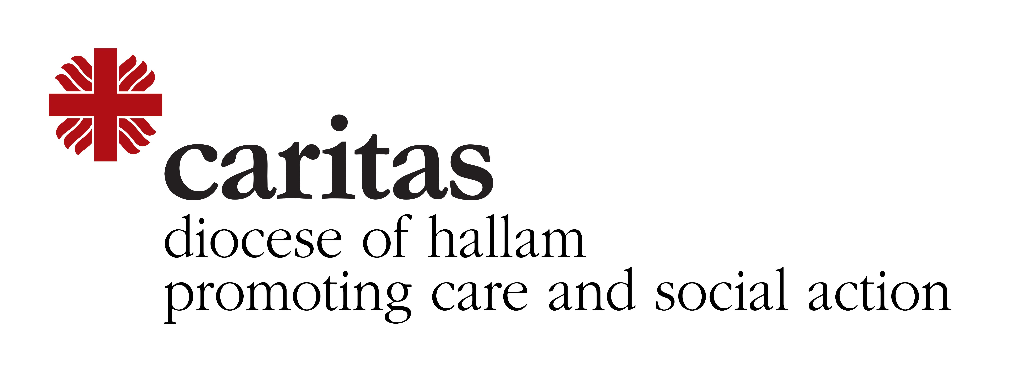
Would you like to help transform the lives of a refugee family in your local community?

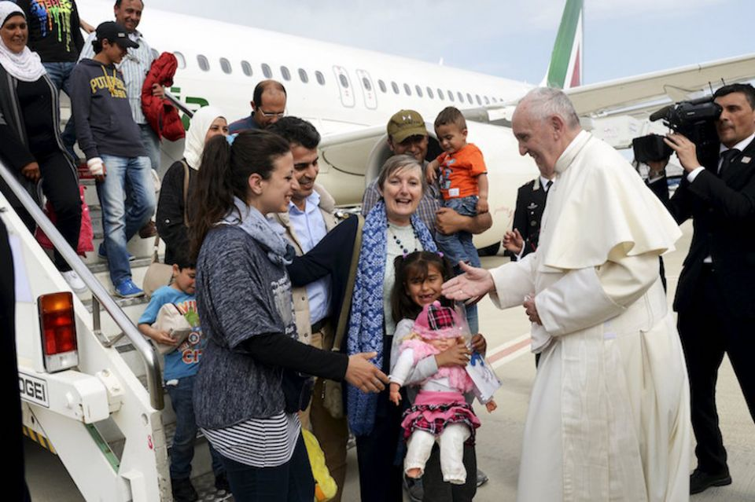

In 2015, Pope Francis declared “May every parish, every religious community, every monastery, every sanctuary in Europe host a refugee family, starting with my own diocese of Rome”.

There are some 70 million people displaced around our world, enduring unimaginable hardship and our diocese has been thinking about how we could respond to this refugee crisis, along the lines suggested by Pope Francis. We’ve decided to ask parishes in Hallam to consider being part of the Community Sponsorship scheme.
Community Sponsorship (CS) is a way to welcome and resettle refugee families. St Monica’s, a parish in Salford Diocese, pioneered the scheme in 2016 and parishes throughout England & Wales have followed suit. Through becoming involved in CS, parishes are taking responsibility for helping a refugee family to build a new life by:
- Preparing a home for the family
- Welcoming the family when they arrive
- Ensuring they settle in well and can access services
- Arranging schools for the children
- Helping the adults learn English and supporting them to find work
Sponsored families arrive with full, legal, refugee status and the right to work, school places, free healthcare, English tuition (ESOL) and State benefits. You will need to find a home for the family (but not to pay for it), raise some money to cover the cost of the family’s initial expenses and plan and develop a programme of resettlement for the family.
"I am convinced that the arrival of our Syrian family is one of the greatest blessings our parish could have received. The energy and goodwill that it has unleashed is remarkable” Fr Tim Buckley, Parish Priest, Liverpool.

“The whole experience has been joyful and profound – transforming lives to a soundtrack of shared jokes, playfulness, singing and laughter. Any parish can do it” Project Manager, St Monica’s, Salford

We hope very much your parish would like to come on board. If you’d like to find out more about becoming involved, please contact Sue Tym at stym@hallam-diocese.com

