Act of Worship

SPECIAL PEOPLE
Year 1

Focal Point: Candle

Gathering
Together
Bible (opened at Luke 2:23-40)
Any pictures/photos of people who are special to the children.
Any pictures of our parish family
(light the candle and sit in a semi-circle)

Leader: We gather In the name of the Father and of the Son and of the Holy Spirit Amen.
Gathering hymn eg Circle Song

You have all put a picture or photo of someone special to you on the table. Quietly now with eyes closed think of that person. Someone perhaps in your family or another friend or even a special grown up who helps you. What makes them so special? How do they help you? (Now breathe in as you picture your special person and as you breathe out say in your head…“thank you God for……” )
We also thank God for all the special people in our parish family, our priest, altar servers, readers, ministers and everyone who welcomes us to the parish community.

Reader: We are going to listen to the story told by St. Luke of the first time that Jesus was taken as a baby to the Temple by Mary and Joseph.
The Word of God
We greet the Gospel with the “Alleluia”
A reading from the Gospel of St Luke
“Mary and Joseph took Jesus to the Temple. He was their baby boy and they wanted to thank God for him. At the temple they met an old man called Simeon. He was a good and holy person. He often went to the Temple to pray. Simeon took Jesus in his arms and praised God. He said, “This baby will bring light and joy to the world.” Mary and Joseph were very surprised by Simeon’s words and didn’t understand what he meant at the time. Simeon blessed them.

After that they met Anna. She was 84 years old and spent all her time in the Temple praying. She said a thank you prayer to God for Jesus and told everyone that he would bring happiness to everyone who loved God.

Mary and Joseph took Jesus home to Nazareth where he grew up and learned to praise God.

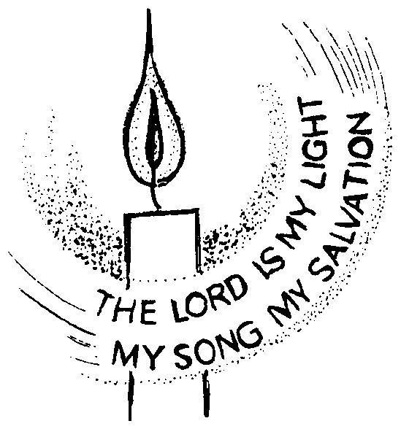
Reader: The Gospel of the Lord
All: Praise to you, Lord Jesus Christ

Now think about Simeon… how happy he was to see (at last) this special baby! Close your eyes and imagine what his words mean… can you picture the baby Jesus (shining like a light for everyone to see… or the happy faces of Simeon and Anna as they look at the longed for baby)
(Some of the reflection already experienced around the Nativity scene will help the children with this.)
Response to
the Word

Leader: We can join in a litany (prayer) together
thanking God for Jesus-with-us-now.

Child: For Mary who cared for Jesus

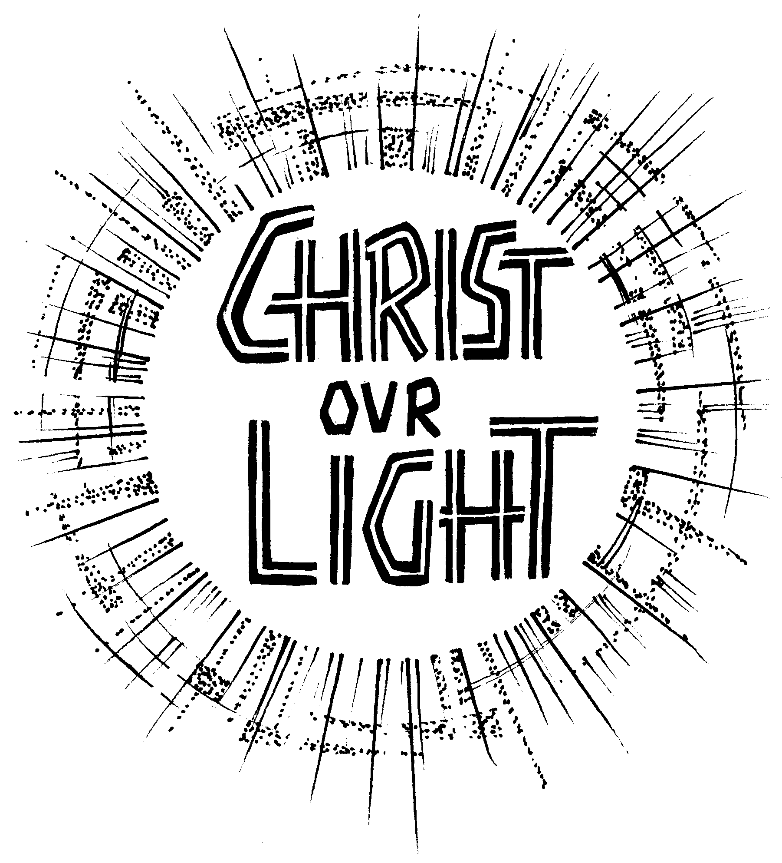 All: Thank you God
Child: For Joseph who looked after Jesus

All: Thank you God
Child: For Simeon who gave thanks for Jesus

All: Thank you God
Child: For Anna who was happy to see him

All: Thank you God
Child: For our parish family of St ______

All: Thank you God
Child: For the special people in our lives

All: Thank you God
Child: For Jesus who loves us all

All: Thank you God

Going
Forth
Perhaps we can think quietly about how we could bring light and joy to the people around us, the special people in our lives and our parish family?

We will finish our time together by singing………
This little light of mine
Shine Jesus shine

In the name of the Father and of the Son and of the Holy Spirit Amen.

