Diocese of Hallam Schools’ Department
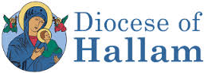
COURSE BOOKING FORM: 2019-20
Please return this form by email to Amanda Bramall at abramall@hallam-diocese.com when booking a place on either course. Once the form has been received, please note that late cancellation or non-attendance will incur a charge of the course fee.
NAME OF SCHOOL: ____________________________
We would like to book a place for the following member(s) of staff:
Name of Course | Date | Member(s) of Staff

Name of person making the booking: ........................................................

Please note: There is a course fee for each booking (Maximum £70)

