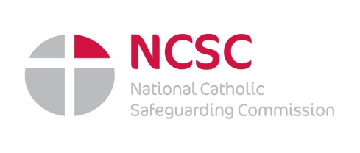
Towards a Culture of Safeguarding:
E-Learning Safeguarding Awareness

The Catholic Trust for England and Wales has purchased a package of e-learning programmes available to all members of the Catholic community free of charge. This is part of the Church’s ongoing commitment to safeguarding.

- Child Protection & Child Protection Refresher
- Child Protection in Education
- An Introduction to Child Sexual Exploitation
- Online Safety
- Safeguarding Adults & Safeguarding Adults Refresher
- Mental Capacity

What do I need to do to access this training resource?

1. To register your interest please email: safeguardingadmin@hallam-diocese.com
2. Your email should contain your name, the name of your parish/order/ congregation, and your role (for example: Priest; member of the Religious;
Safeguarding Representative; Youth Worker; Teacher; SVP/Volunteer;
Parent/Grandparent/Guardian; Other.
3. On receipt of your email the safeguarding administrator will register your
email address with EduCare.
4. You will receive a welcome email from EduCare inviting you to set your
password.
5. You will then have instant access to the training programmes.
Further log in information is available and can be emailed on request.
A Certificate can be printed after completion of each module which may count towards evidence of your CPD (Continuing Professional Development).

