Annual Safeguarding Event

Mental Health Awareness Day
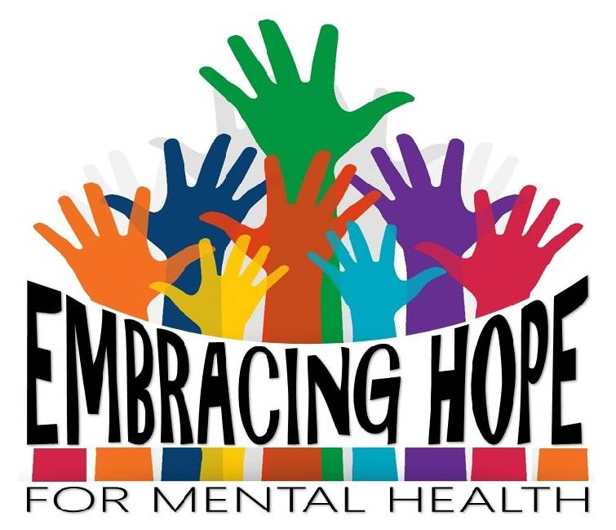
Mental illness is real……. but so is hope.

Saturday 10th November 2018
St Marys Catholic Primary School,
Pack Horse Lane, High Green Sheffield, S35 3HY
Clergy, Safeguarding Representatives, Parishioners are all welcome
Lunch is included.
Programme Schedule
09:00am-09:30am: Mass - St Mary’s Catholic Church, Mortomley Lane, High Green, Sheffield, S35 3HS .
09:45am-Welcome: Charles Neal, Safeguarding Commission Chair & Colette Hammill, Safeguarding Co-ordinator.
10:00am-11.30am: Simon Francis - An Introduction to Mental Health
The session will focus on raising awareness of mental health problems, looking at the stigma and discrimination that still surrounds mental health, statistics and also what support is available.
11:30am-11.45am: BREAK
11.45am-1.00pm: Simon Francis (cont:)
1:00pm-1.30pm LUNCH
1:30pm-3.15pm: Baroness Sheila Hollins - Mental Health, Learning
Disabilities and Abuse

Baroness Hollins will be discussing the impact of abuse on mental health. She will focus on mental health for survivors of abuse, including those with learning disabilities.
3:15pm-3.30pm: BREAK
3:30pm-3.55pm: Laura Rendell - Mindfulness
The session will focus on Mindfulness as a method of improving mental health. This will include delegates experiencing the process of being in the present moment.
4:00pm: Bishop Ralph Heskett – Prayer and Close
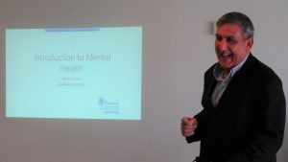

Simon Francis, Sheffield Mind.
Simon Francis is a former Senior Policy Advisor, who has worked in several government departments advising Ministers and senior officials on Mental Health, Disability, and Employment.
Simon has also led on and delivered several national strategies for health and work. He has published research on the relationship between health and work, a cost benefit analysis of employment programmes, and what works in helping people with mental health conditions find work, among other areas.
Simon has experience working in both the private and voluntary sector, including consultancy for Sheffield City Region and Greater Manchester Health and Social Care.

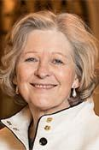
Baroness Sheila Hollins
Sheila Hollins is Emeritus Professor of Psychiatry of Learning Disability at St. George's, University of London, and a former Consultant Psychiatrist. She is a Crossbench member of the House of Lords and honorary visiting professor in the Department of Theology, Durham University.

Sheila was a founder member of the Pontifical Commission for the Protection of Minors for 4 years from 2014 to 2017. She chairs the Scientific Advisory Board of the Centre for Child Protection at the Pontifical Gregorian University in Rome.

Sheila is a past president of the Royal College of Psychiatrists and of the BMA, and currently President of the Royal College of Occupational Therapists. She is the founder, Editor and Chair of Books Beyond Words, and a family carer for her son who has a learning disability.

Sheila is married with four children and four grandchildren and was brought up in Chapeltown.

Laura Rendell
Working for Hallam Caring Services, Laura is a qualified Counsellor and Psychotherapist and a trainer in Mindfulness.
Laura works as a Counsellor with children in our Catholic schools and also counsels adults within the wider community. She has delivered workshops on mindfulness to teachers and ancillary staff in schools. She uses mindfulness technique in her practice on a daily basis in order that clients are able to become more compassionate in their lives.
“Mindfulness meditation is the best natural tonic for the troubled mind and body I have ever discovered.” (Carmody Grey – Assistant Professor in Catholic theology at Durham University)
Laura will be ending the day with a short workshop on Mindfulness followed by a closing speech from Bishop Ralph Heskett.

Mental illness knows no boundaries. It crosses all lines of gender, race,
financial status, social status, sexual-orientation, cultures and religions.

When public figures open up about their own mental health struggles it
can help to break down stigma, spark important discussions, and even
inspire people to seek treatment.

With the help and patient nurturing given by you the professionals, family and friends, people suffering from Eating Disorders can find a better way of coping with their lives, by learning to deal with their problems directly in a safe and supportive environment.
RIP Princess Diana
