HALLAM CATHOLIC SAFEGUARDING COMMISSION
Hallam Pastoral Centre, St Charles Street, Sheffield S9 3WU
Safeguarding Co-ordinator: Lisa Markham
Landline: 0114 256 6454 Work Mobile: 07909 117964
Email: lmarkham@hallam-diocese.com

Christmas Safeguarding Newsletter for
Local Safeguarding Reps / Designated Link Persons / Clergy

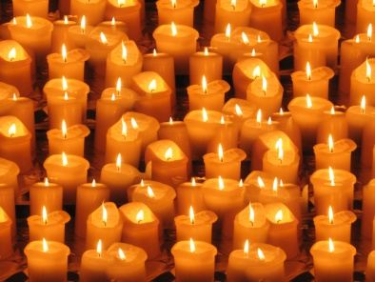
1. Seasons Greetings

This has been an exceptionally busy year with a rise in overall workload, changes in legislation and guidance, and changes at the head offices of the Catholic Safeguarding Advisory Service. This newsletter is to bring you up to date with some of those developments.

2. Staff Changes

CSAS officers have moved to the CBCEW offices (39 Eccleston Square, London, SW1V 1BX) and most staff previously located in Birmingham have left the employ of the Birmingham team. The post of National Director has been advertised and interviews are taking place the week beginning 15.12.2014.

If you need to contact CSAS directly, you can use the Birmingham number for a period of time. Calls and post will be routed to the new office. The main office number is 020 7901 1920.

From 1st November, CSAS staffing complement will be:
Jo Utteridge – PA/Office Manager
Frankie Thomas – Administrator
Carol Parry – Learning & Development Adviser (p/t from 1st January 2015)
Adrian Child – Director (going p/t at some point in 2015 to assist new handover to new Director)
Jackie Hunt – Administrator (Birmingham)

Another Admin Assistant will be recruited to start in November 2015.

There are some changes in our office too as Julie Howorth has concluded her work at the Hurt by Abuse pilot project, and Emma Shaw has been offered work for the Diocese, specifically helping to revamp the Diocesan website.

3. DBS / Safe Recruitment Issues
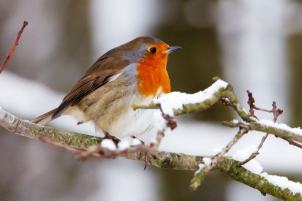
Due to changes in the legislation in April 2015, we will all need to be much more rigorous in ensuring that no volunteer or paid worker is in role without having completed the recruitment and DBS process.
The safeguarding office will host a training session in February/March 2015.

A new system of processing DBS is currently being piloted in some Dioceses, and there is expectation that all Dioceses will move to this system, which promises simplification and less paper.

Watch this space!

4. Hurt By Abuse

An executive summary of the pilot project in Hallam will be available on the website in the New Year, and there will be a section which addresses the questions and issues raised via the questionnaire which was circulated to all parishes and groups. The plans for a national project are well underway. In the interim, we will be trying to recruit a part time facilitator to carry on the good work that Julie started. The next round of Hurt by Abuse seminars will take place at the Chesterfield Deanery.

5. Training

Most of our efforts this year have focussed on delivering the 3 day Towards a Culture of Safeguarding Training for Reps and Clergy. We are experimenting with volunteers and a couple of external facilitators delivering the training, and trying to “slow down” the content to accommodate our many volunteers who also have work commitments.
We are also exploring the possibility of delivering some of our training and awareness sessions via “Webinars”, which should allow more people to participate with minimal time commitments.

In addition, there will be an online e-learning package tailored to those working, ministering or volunteering within the Catholic Church available from March 2015.
This is free to all regardless of role, with the costs of implementation borne by Head Office rather than Dioceses. This includes basic safeguarding awareness, e-safety and child sexual exploitation.
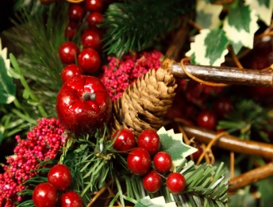
Details of training provided by other organisations will continue to be advertised on the website and by newsletters.

6. Safe Practice Issues

Please keep an eye on the website for development of the Frequently Asked Questions section. Issues which have arisen recently include storage and management of sensitive information, lots of questions about vulnerable adults or adults who may be at risk, and e-safety. There will be further briefings and relevant training in the New Year.
As its Christmas with nativities, celebrations and pantomimes, please remember the absolute requirements to obtain consent before taking and displaying photographs and images. Please check out the “Creating a Safe Environment” section of the CSAS procedures on their website.

A new Safeguarding resource pack will be available in the New Year. This is a safeguarding resource available to all.
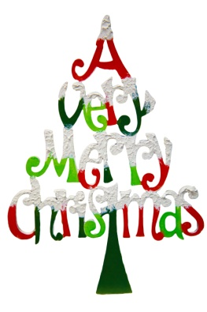
And finally...

The Safeguarding Team thanks you for all the support you give us and for your huge contribution to our safeguarding endeavour. Go well, stay safe and God bless.

Lisa, Fr Peter, Jo, Amanda and Emma

