HALLAM CATHOLIC SAFEGUARDING COMMISSION
Hallam Pastoral Centre, St Charles Street, Sheffield S9 3WU
Safeguarding Co-ordinator: Lisa Markham
Landline: 0114 256 6454 Work Mobile: 07909 117964
Email: lmarkham@hallam-diocese.com

Safeguarding Newsletter
Local Safeguarding Reps / Designated Link Persons / Parish Priests

1. Christmas News

Please look out for a mailing before Christmas which contains a copy of the December ChurchSafe newsletter amongst other things. Ideally these are for distribution to volunteers. They can be displayed in your churches and church halls, and a copy will be available on the Diocesan website.

2. Website Development

In a letter from the Chair of NCSC Danny Sullivan to Archbishops, Bishops, Commission Chairs and Safeguarding Staff in October, he commented “I hope you might be as surprised as I am that there are a number of Diocese which still have no information on their website about the Safeguarding Office...”
Thankfully in the Diocese of Hallam, Emma is doing sterling work on the Safeguarding section of the Diocesan website. We want to make this as interactive as possible and welcome your ongoing comments and contributions. Emma is also doing a review of Parish websites which might help the Diocesan office and possibly identify some areas for improvement.

3. Safeguarding Good Practice

Thank you to all who attended the Diocesan Support Meetings and to Tom Garrud (Diocesan Property Manager) who introduced the Health and Safety Toolkit. The meeting looked at Health and Safety procedures and links with Safeguarding/Creating Safe Environments.
Some of you have already begun using the Safe Environment audit tool that we trialled – many thanks for your enthusiasm. We will send all further guidance about this task in the New Year.

4. Hurt By Abuse

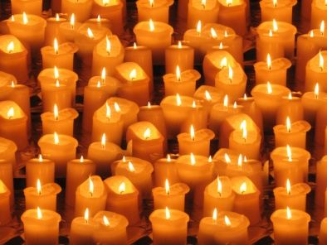
The Hurt By Abuse project is well under way and we will be repeating the talks, with some new speakers and topics in the next few months. Lisa Markham met recently with a group of survivors, representatives of survivors support organisations and Fr. Bob Oliver, the Promoter of Justice for the Congregation of the Doctrine of the Faith in November. This was a very productive meeting in which Fr. Oliver repeated the message from Pope Francis that “victims must come first”.
Lisa is also working with Tina Campbell, National Director of Scottish Catholic Office for Safeguarding, to produce some guidelines for liturgy and worship which is sensitive to the needs of those who have been hurt in a faith setting, and some other practical guidance around pastoral support.

5. DBS Matters

In addition, the Deanery support meeting considered changes to DBS processes and paperwork: detailed guidelines will appear on the website but some critical points to bear in mind are:
- The applicant is the only person to have a copy of the DBS certificate, which must, on receipt, be sent to the safeguarding office within 28 days.
- The certificate will be returned to the applicant immediately, following approval by the safeguarding office.
- Receipt of the DBS is not by itself a guarantee that a person can be appointed. Safeguarding Reps/DLPs and clergy must await receipt of a formal letter from the Safeguarding Office confirming suitability.
- We are encouraging people who have a DBS through the Diocese to register that certificate online; one advantage being that it may save multiple/repeat checks in the future. This must be done within 14 days so ideally before the certificate is sent to the office.
The guidance for online registration is always in the DBS pack, and a simplified version will be available on the Safe Recruitment Section of the website shortly.

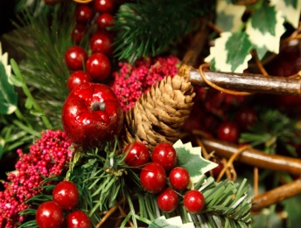
And finally...

As we approach the Nativity, a practical dilemma in many workplaces is ‘Do I give a card to my colleagues?’
This year we have chosen to save trees, being mindful of the environment and time, and to send donations direct to CAFOD and St Wilfrid’s Sponsorship fund in lieu of cards.
Much as we have enjoyed the ritual of writing personal messages via Christmas cards to Reps and Clergy and all who support safeguarding, we are also mindful of cost and cards weight heavy!

Imagine this missive as a big, shared card which binds us together. Enjoy, be receptive to what this season brings and be safe. And thank you.
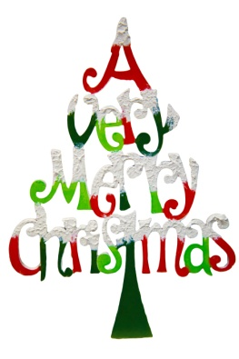
Lisa, Fr Peter, Jo, Amanda, Emma and Julie

Clergy Adviser for Safeguarding: Rev Peter D McGuire
Tel 01246 432289 Email: pdmcg@btinternet.com
Office: Administrator 0114 256 6453 Email: safeguardingadmin@hallam-diocese.com
Registered Charity No. 512021

