**My Personal Prayer**

**Journey through Year Six**

God of stillness and  
creative action,  
help us to find space  
for quietness today  
that we may live  
creatively,  
discover the inner   
meaning of silence,  
and learn the  
wisdom  
that heals the world.  
Send peace and joy  
to each quiet place,  
to all who are  
waiting   
and listening.  
May your still small  
voice be heard  
through Christ, in  
the love of the Spirit  
Amen.

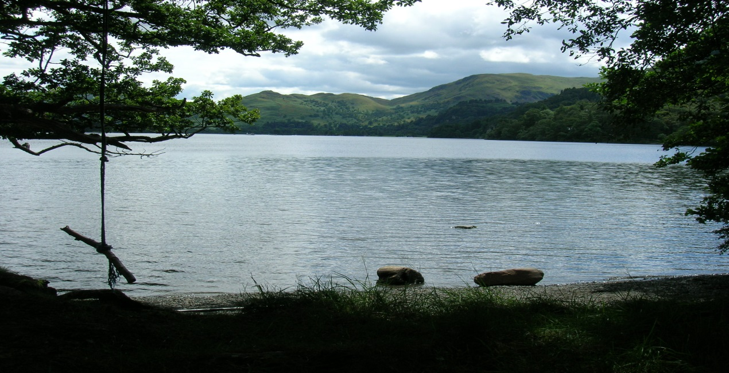

**A YEAR SIX PRAYER JOURNAL**

***Dear Pupils,***

***“Be still and know that I am God” (Psalm 46:10)***

**An introduction to the skill of ‘Prayer Journaling’ for pupils in Year Six:**

Being still, clearing our minds of distraction, relaxing and ‘not doing anything’ for a little while is something we don’t often get chance to do and when we do, we sometimes think we are wasting our time! However, ‘just being’ offers us a wonderful opportunity for reflection, imagination and contemplation. In times of silence and stillness, we are reminded that we are human ‘beings’ not human ‘doings’ and that following gentle times of ‘structured stillness or meditation’, we can often feel very refreshed, re-energized and more able to ‘do things well’.

**“Be still and know that I am God**” said the psalmist, for spending time in silence, in God’s presence is a gift and allowing ourselves the space to do this is something we should all take the opportunity to do. One of the best ways we can do this is by creating our very own special prayer journal.

One of the great things about creating a prayer journal is that there is no one way to journal, no set pattern to follow and therefore no need to worry if we are ‘doing it’ right. You may like to date your entries but you don’t have to. Some people journal by writing lots, some people doodle; some people write poems; some people sketch; some people write down the names of people they are praying for; some people use their journals to express their worries, their hopes, their feelings to God.

Your journal is private – you only share it with anyone else if you want to. Each time we journal, quiet, meditative music will be played to help us all be calm and relax. We will know how long we have to journal and we will be told we will be finishing a few minutes before the end to enable us to ‘gently’ complete what we are doing. Sometimes, we have a special focus or prompt for us all to consider. When we complete our time of journaling, our journals will be locked away in a safe place ready for next time unless you would like yours to be seen by someone else. At the end of the journal there is a selection of prayers with space for you to copy them if you wish or add your own.

However you choose to use your journal it is important to remember that it is very personal to you and that you will be able to take it home at the end of the year if you would like to. We think your prayer journal will become a very special personal book which will help you to take time out in the stillness of your own heart and hear what God is saying to you.

May God bless you and guide you on your journey through Year Six and on your inner journey as you create your very own prayer journal.

**Lord, I lay before you all my hopes, my dreams and wishes, and any fears I may have………………………..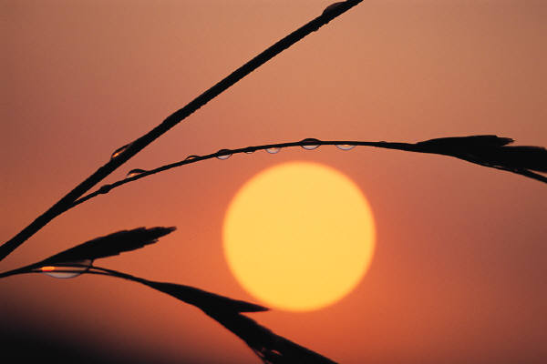**

***Be still for the presence of the Lord.***

***Lord, today I thank you for…………..***

***\_\_\_\_\_\_\_\_\_\_\_\_\_\_\_\_\_\_\_\_\_\_\_\_\_\_\_\_\_\_\_\_\_\_\_\_\_\_\_\_\_\_\_\_\_\_\_\_\_\_\_\_\_\_\_\_\_\_\_\_\_\_\_\_\_\_\_\_\_\_\_\_\_\_\_\_\_\_\_\_\_\_\_\_\_\_\_\_\_\_\_\_\_\_\_\_\_\_\_\_\_\_\_\_\_\_\_\_\_\_\_\_\_\_\_\_\_\_\_\_\_\_\_\_\_\_\_\_\_\_\_\_\_\_\_\_\_\_\_\_\_\_\_\_\_\_\_\_\_\_\_\_\_\_\_\_\_\_\_\_\_\_\_\_\_\_\_\_\_\_\_\_\_\_\_\_\_\_\_\_\_\_\_\_\_\_\_\_\_\_\_\_\_\_\_\_\_\_\_\_\_\_\_\_\_\_\_\_\_\_\_\_\_\_\_\_\_\_\_\_\_\_\_\_\_\_\_\_\_\_\_\_\_\_\_\_\_\_\_\_\_\_\_\_\_\_\_\_\_\_\_\_\_\_\_\_\_\_\_\_\_\_\_\_\_\_\_\_\_\_\_\_\_\_\_\_\_\_\_\_\_\_\_\_\_\_\_\_\_\_\_\_\_\_\_\_\_\_\_\_\_\_\_\_\_\_\_\_\_\_\_\_\_\_\_\_\_\_\_\_\_\_\_\_\_\_\_\_\_\_\_\_\_\_\_\_\_\_\_\_\_\_\_\_\_\_\_\_\_\_\_\_\_\_\_\_\_\_\_\_\_\_\_\_\_\_\_\_\_\_\_\_\_\_\_\_\_\_\_\_\_\_\_\_\_\_\_\_\_\_\_\_\_\_\_\_\_\_\_\_\_\_\_\_\_\_\_\_\_\_\_\_\_\_\_\_\_\_\_\_\_\_\_\_\_\_\_\_\_\_\_\_\_\_\_\_\_\_\_\_\_\_\_\_\_\_\_\_\_\_\_\_\_\_\_\_\_\_\_\_\_\_\_\_\_\_\_\_\_\_\_\_\_\_\_\_\_\_\_\_\_\_\_\_\_\_\_\_\_\_\_\_\_\_\_\_\_\_\_\_\_\_\_\_\_\_\_\_\_\_\_\_\_\_\_\_\_\_\_\_\_\_\_\_\_\_\_\_\_\_\_\_\_\_\_\_\_\_\_\_\_\_\_\_\_\_\_\_\_\_\_\_\_\_\_\_\_\_\_\_\_\_\_\_\_\_\_\_\_\_\_\_\_\_\_\_\_\_\_\_\_\_\_\_\_\_\_\_\_\_\_\_\_\_\_\_\_\_\_\_\_\_\_\_\_\_\_\_\_\_\_\_\_\_\_\_\_\_\_\_\_\_\_\_\_\_\_\_\_\_\_\_\_\_\_\_\_\_\_\_\_\_\_\_\_\_\_\_\_\_\_\_\_\_\_\_\_\_\_\_\_\_\_\_\_\_\_\_\_\_\_\_\_\_\_\_\_\_\_\_\_\_\_\_\_\_\_\_\_\_\_\_\_\_\_\_\_\_\_\_\_\_***

***j0156073***

***If you were to meet Jesus face to face, what would you say to Him, what do you think He might say to you?***

#### \_\_\_\_\_\_\_\_\_\_\_\_\_\_\_\_\_\_\_\_\_\_\_\_\_\_\_\_\_\_\_\_\_\_\_\_\_\_\_\_\_\_\_\_\_\_\_\_\_\_\_\_\_\_\_\_\_\_\_\_\_\_\_\_\_\_\_\_\_\_\_\_\_\_\_\_\_\_\_\_\_\_\_\_\_\_\_\_\_\_\_\_\_\_\_\_\_\_\_\_\_\_\_\_\_\_\_\_\_\_\_\_\_\_\_\_\_\_\_\_\_\_\_\_\_\_\_\_\_\_\_\_\_\_\_\_\_\_\_\_\_\_\_\_\_\_\_\_\_\_\_\_\_\_\_\_\_\_\_\_\_\_\_\_\_\_\_\_\_\_\_\_\_\_\_\_\_\_\_\_\_\_\_\_\_\_\_\_\_\_\_\_\_\_\_\_\_\_\_\_\_\_\_\_\_\_\_\_\_\_\_\_\_\_\_\_\_\_\_\_\_\_\_\_\_\_\_\_\_\_\_\_\_\_\_\_\_\_\_\_\_\_\_\_\_\_\_\_\_\_\_\_\_\_\_\_\_\_\_\_\_\_\_\_\_\_\_\_\_\_\_\_\_\_\_\_\_\_\_\_\_\_\_\_\_\_\_\_\_\_\_\_\_\_\_\_\_\_\_\_\_\_\_\_\_\_\_\_\_\_\_\_\_\_\_\_\_\_\_\_\_\_\_\_\_\_\_\_\_\_\_\_\_\_\_\_\_\_\_\_\_\_\_\_\_\_\_\_\_\_\_\_\_\_\_\_\_\_\_\_\_\_\_\_\_\_\_\_\_\_\_\_\_\_\_\_\_\_\_\_\_\_\_\_\_\_\_\_\_\_\_\_\_\_\_\_\_\_\_\_\_\_\_\_\_\_\_\_\_\_\_\_\_\_\_\_\_\_\_\_\_\_\_\_\_\_\_\_\_\_\_\_\_\_\_\_\_\_\_\_\_\_\_\_\_\_\_\_\_\_\_\_\_\_\_\_\_\_\_\_\_\_\_\_\_\_\_\_\_\_\_\_\_\_\_\_\_\_\_\_\_\_\_\_\_\_\_\_\_\_\_\_\_\_\_\_\_\_\_\_\_\_\_\_\_\_\_\_\_\_\_\_\_\_\_\_\_\_\_\_\_\_\_\_\_\_\_\_\_\_\_\_\_\_\_\_\_\_\_\_\_\_\_\_\_\_\_\_\_\_\_\_\_\_\_\_\_\_\_\_\_\_\_\_\_\_\_\_\_\_\_\_\_\_\_\_\_\_\_\_\_\_\_\_\_\_\_\_\_\_\_\_\_\_

#### *The earth is the Lord's and everything in it, the world and all who live in it; for He founded it upon the seas and established it upon the waters. Psalm 24: 1 - 2*

|  |  |  |  |
| --- | --- | --- | --- |
| **Mountain scene in sunset** |  |  |  |

**\_\_\_\_\_\_\_\_\_\_\_\_\_\_\_\_\_\_\_\_\_\_\_\_\_\_\_\_\_\_\_\_\_\_\_\_\_\_\_\_\_\_\_\_\_\_\_\_\_\_\_\_\_\_\_\_\_\_\_\_\_\_\_\_\_\_\_\_\_\_\_\_\_\_\_\_\_\_\_\_\_\_\_\_\_\_\_\_\_\_\_\_\_\_\_\_\_\_\_\_\_\_\_\_\_\_\_\_\_\_\_\_\_\_\_\_\_\_\_\_\_\_\_\_\_\_\_\_\_\_\_\_\_\_\_\_\_\_\_\_\_\_\_\_\_\_\_\_\_\_\_\_\_\_\_\_\_\_\_\_\_\_\_\_\_\_\_\_\_\_\_\_\_\_\_\_\_\_\_\_\_\_\_\_\_\_\_\_\_\_\_\_\_\_\_\_\_\_\_\_\_\_\_\_\_\_\_\_\_\_\_\_\_\_\_\_\_\_\_\_\_\_\_\_\_\_\_\_\_\_\_\_\_\_\_\_\_\_\_\_\_\_\_\_\_\_\_\_\_\_\_\_\_\_\_\_\_\_\_\_\_\_\_\_\_\_\_\_\_\_\_\_\_\_\_\_\_\_\_\_\_\_\_\_\_\_\_\_\_\_\_\_\_\_\_\_\_\_\_\_\_\_\_\_\_\_\_\_\_\_\_\_\_\_\_\_\_\_\_\_\_\_\_\_\_\_\_\_\_\_\_\_\_\_\_\_\_\_\_\_\_\_\_\_\_\_\_\_\_\_\_\_\_\_\_\_\_\_\_\_\_\_\_\_\_\_\_\_\_\_\_\_\_\_\_\_\_\_\_\_\_\_\_\_\_\_\_\_\_\_\_\_\_\_\_\_\_\_\_\_\_\_\_\_\_\_\_\_\_\_\_\_\_\_\_\_\_\_\_\_\_\_\_\_\_\_\_\_\_\_\_\_\_\_\_\_\_\_\_\_\_\_\_\_\_\_\_\_\_\_\_\_\_\_\_\_\_\_\_\_\_\_\_\_\_\_\_\_\_\_\_\_\_\_\_\_\_\_\_\_\_\_\_\_\_\_\_\_\_\_\_\_\_\_\_\_\_\_\_\_\_\_\_\_\_\_\_\_\_\_\_\_\_\_\_\_\_\_\_\_\_\_\_\_\_\_\_\_\_\_\_\_\_\_\_\_\_\_\_\_\_\_\_\_\_\_\_\_\_\_\_\_\_\_\_\_\_\_\_\_\_\_\_\_\_\_\_\_\_\_\_\_\_\_\_\_\_\_\_\_\_\_\_\_\_\_\_\_\_\_\_\_\_\_\_\_\_\_\_\_\_\_\_\_\_\_\_\_\_\_\_\_\_\_\_\_\_\_\_\_\_\_\_\_\_\_\_\_\_\_\_\_\_\_\_\_\_\_\_\_\_\_\_\_\_\_\_\_\_\_\_\_\_\_\_\_\_\_\_\_\_\_\_\_\_\_\_\_\_\_\_\_\_\_\_\_\_\_\_\_\_\_\_\_\_\_\_\_\_\_\_\_\_\_\_\_\_\_\_\_\_\_\_\_\_\_\_\_\_\_\_\_\_\_\_\_\_\_\_\_\_\_\_\_\_\_\_\_\_\_\_\_\_\_\_\_\_\_\_\_\_\_\_\_\_\_\_\_\_\_\_\_\_\_\_\_\_\_\_\_\_\_\_\_\_\_\_\_\_\_\_\_\_\_\_\_\_\_\_\_\_\_\_\_\_\_\_\_\_\_\_\_\_\_\_\_\_\_\_\_\_\_\_\_\_\_\_\_\_\_**

**God grant me the serenity**

**To accept the things I cannot change;**

**Courage to change the things I can; and wisdom to know the difference.**

dd00008_

**\_\_\_\_\_\_\_\_\_\_\_\_\_\_\_\_\_\_\_\_\_\_\_\_\_\_\_\_\_\_\_\_\_\_\_\_\_\_\_\_\_\_\_\_\_\_\_\_\_\_\_\_\_\_\_\_\_\_\_\_\_\_\_\_\_\_\_\_\_\_\_\_\_\_\_\_\_\_\_\_\_\_\_\_\_\_\_\_\_\_\_\_\_\_\_\_\_\_\_\_\_\_\_\_\_\_\_\_\_\_\_\_\_\_\_\_\_\_\_\_\_\_\_\_\_\_\_\_\_\_\_\_\_\_\_\_\_\_\_\_\_\_\_\_\_\_\_\_\_\_\_\_\_\_\_\_\_\_\_\_\_\_\_\_\_\_\_\_\_\_\_\_\_\_\_\_\_\_\_\_\_\_\_\_\_\_\_\_\_\_\_\_\_\_\_\_\_\_\_\_\_\_\_\_\_\_\_\_\_\_\_\_\_\_\_\_\_\_\_\_\_\_\_\_\_\_\_\_\_\_\_\_\_\_\_\_\_\_\_\_\_\_\_\_\_\_\_\_\_\_\_\_\_\_\_\_\_\_\_\_\_\_\_\_\_\_\_\_\_\_\_\_\_\_\_\_\_\_\_\_\_\_\_\_\_\_\_\_\_\_\_\_\_\_\_\_\_\_\_\_\_\_\_\_\_\_\_\_\_\_\_\_\_\_\_\_\_\_\_\_\_\_\_\_\_\_\_\_\_\_\_\_\_\_\_\_\_\_\_\_\_\_\_\_\_\_\_\_\_\_\_\_\_\_\_\_\_\_\_\_\_\_\_\_\_\_\_\_\_\_\_\_\_\_\_\_\_\_\_\_\_\_\_\_\_\_\_\_\_\_\_\_\_\_\_\_\_\_\_\_\_\_\_\_\_\_\_\_\_\_\_\_\_\_\_\_\_\_\_\_\_\_\_\_\_\_\_\_\_\_\_\_\_\_\_\_\_\_\_\_\_\_\_\_\_\_\_\_\_\_\_\_\_\_\_\_\_\_\_\_\_\_\_\_\_\_\_\_\_\_\_\_\_\_\_\_\_\_\_\_\_\_\_\_\_\_\_\_\_\_\_\_\_\_\_\_\_\_\_\_\_\_\_\_\_\_\_\_\_\_\_\_\_\_\_\_\_\_\_\_\_\_\_\_\_\_\_\_\_\_\_\_\_\_\_\_\_\_\_\_\_\_\_\_\_\_\_\_\_\_\_\_\_\_\_\_\_\_\_\_\_\_\_\_\_\_\_\_\_\_\_\_\_\_\_\_\_\_\_\_\_\_\_\_\_\_\_\_\_\_\_\_\_\_\_\_\_\_\_\_\_\_\_\_\_\_\_\_\_\_\_\_\_\_\_\_\_\_\_\_\_\_\_\_\_\_\_\_\_\_\_\_\_\_\_\_\_\_\_\_\_\_\_\_\_\_\_\_\_\_\_\_\_\_\_\_\_\_\_\_\_\_\_\_\_\_\_\_\_\_\_\_\_\_\_\_\_\_\_\_\_\_\_\_\_\_\_\_\_\_\_\_\_\_\_\_\_\_\_\_\_\_\_\_\_\_\_\_\_\_\_\_\_\_\_\_\_\_\_\_\_\_\_\_\_\_\_\_\_\_\_\_\_\_\_\_\_\_\_\_\_\_\_\_\_\_\_\_\_\_\_\_\_\_\_\_\_\_\_\_\_\_\_\_\_\_\_\_\_\_\_\_\_\_\_\_\_\_\_\_\_\_\_\_\_\_\_\_\_\_\_\_\_\_\_\_\_\_\_\_\_\_\_\_\_\_\_\_\_\_**

“ ***So he returned home to his Father.***

***And while he was still a long distance away, his Father saw him coming.***

***Filled with love and compassion, he ran to his son, embraced him, and kissed him.***

***Luke 15:20***

**dd00008_**

\_\_\_\_\_\_\_\_\_\_\_\_\_\_\_\_\_\_\_\_\_\_\_\_\_\_\_\_\_\_\_\_\_\_\_\_\_\_\_\_\_\_\_\_\_\_\_\_\_\_\_\_\_\_\_\_\_\_\_\_\_\_\_\_\_\_\_\_\_\_\_\_\_\_\_\_\_\_\_\_\_\_\_\_\_\_\_\_\_\_\_\_\_\_\_\_\_\_\_\_\_\_\_\_\_\_\_\_\_\_\_\_\_\_\_\_\_\_\_\_\_\_\_\_\_\_\_\_\_\_\_\_\_\_\_\_\_\_\_\_\_\_\_\_\_\_\_\_\_\_\_\_\_\_\_\_\_\_\_\_\_\_\_\_\_\_\_\_\_\_\_\_\_\_\_\_\_\_\_\_\_\_\_\_\_\_\_\_\_\_\_\_\_\_\_\_\_\_\_\_\_\_\_\_\_\_\_\_\_\_\_\_\_\_\_\_\_\_\_\_\_\_\_\_\_\_\_\_\_\_\_\_\_\_\_\_\_\_\_\_\_\_\_\_\_\_\_\_\_\_\_\_\_\_\_\_\_\_\_\_\_\_\_\_\_\_\_\_\_\_\_\_\_\_\_\_\_\_\_\_\_\_\_\_\_\_\_\_\_\_\_\_\_\_\_\_\_\_\_\_\_\_\_\_\_\_\_\_\_\_\_\_\_\_\_\_\_\_\_\_\_\_\_\_\_\_\_\_\_\_\_\_\_\_\_\_\_\_\_\_\_\_\_\_\_\_\_\_\_\_\_\_\_\_\_\_\_\_\_\_\_\_\_\_\_\_\_\_\_\_\_\_\_\_\_\_\_\_\_\_\_\_\_\_\_\_\_\_\_\_\_\_\_\_\_\_\_\_\_\_\_\_\_\_\_\_\_\_\_\_\_\_\_\_\_\_\_\_\_\_\_\_\_\_\_\_\_\_\_\_\_\_\_\_\_\_\_\_\_\_\_\_\_\_\_\_\_\_\_\_\_\_\_\_\_\_\_\_\_\_\_\_\_\_\_\_\_\_\_\_\_\_\_\_\_\_\_\_\_\_\_\_\_\_\_\_\_\_\_\_\_\_\_\_\_\_\_\_\_\_\_\_\_\_\_\_\_\_\_\_\_\_\_\_\_\_\_\_\_\_\_\_\_\_\_\_\_\_\_\_\_\_\_\_\_\_\_\_\_\_\_\_\_\_\_\_\_\_\_\_\_\_\_\_\_\_\_\_\_\_\_\_\_\_\_\_\_\_\_\_\_\_\_\_\_\_\_\_\_\_\_\_\_\_\_\_\_\_\_\_\_\_\_\_\_\_\_\_\_\_\_\_\_\_\_\_\_\_\_\_\_\_\_\_\_\_\_\_\_\_\_\_\_\_\_\_\_\_\_\_\_\_\_\_\_\_\_\_\_\_\_\_\_\_\_\_\_\_\_\_\_\_\_\_\_\_\_\_\_\_\_\_\_\_\_\_\_\_\_\_\_\_\_\_\_\_\_\_\_\_\_\_\_\_\_\_\_\_\_\_\_\_\_\_\_\_\_\_\_\_\_\_

***‘This is what Yahweh asks of you***

***That you walk justly, that you love tenderly***

***That you walk humbly, with your God’***

***Micah 6:8***

**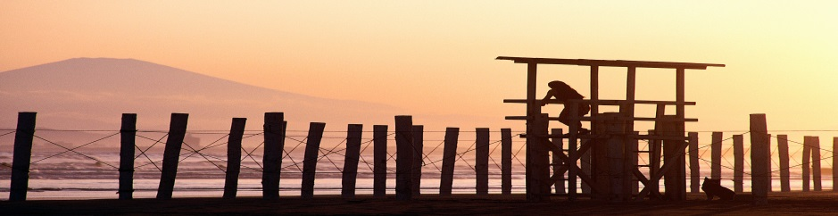**

***Part Two:***

***A selection of prayers for you to consider – some will be very familiar to you, others may be new to you.***

***Have you a favourite one? You may like to copy it out and illustrate it, just like the monks used to copy the Scripture in the old monasteries.***

***You may also like to add other prayers to this section that you have learnt or discovered or created yourself. If you do add prayers to this section please don’t rush when you write them out – just take your time and let the words touch your heart.***

*In the name of the Father, and of the Son,*

*and of the Holy Spirit. Amen.*

*The night has passed and the day lies open to us;*

*we pray with one heart and mind.*

*O my God you love me, you’re with me night and day.*

*I want to love you always in all I do and say.*

*I’ll try to please you Father, bless me through the day. Amen*

*Our Father, who art in heaven, hallowed be thy name. Thy kingdom come, thy will be done on earth as it is in heaven. Give us this day our daily bread, and forgive us our trespasses, as we forgive those who trespass against us, and lead us not into temptation, but deliver us from evil. Amen*

*Glory Be to the Father and to the Son, and to the Holy Spirit. As it was in the beginning, is now, and ever shall be, world without end. Amen.*

*Hail Mary full of grace the Lord is with thee, blessed art thou among women and blessed is the fruit of thy womb, Jesus. Holy Mary, Mother of God, pray for us sinners now and at the hour of our death. Amen.*

*Eternal rest grant unto them, O Lord and let perpetual light shine upon them. May they rest in peace. Amem*

*Angel of God my guardian dear,*

*to whom God’s love commits me here,*

*ever this night (or day) be at my side to light and guard, to rule and guide. Amen*

*Lord make me an instrument of your peace: where there is hatred let me sow love, where there is injury let me sow pardon, where there is doubt let me sow faith, where there is despair let me bring hope, where there is darkness let me give light, where there is sadness let me give joy.*

*(St Francis of Assisi)*

*The grace of Our Lord Jesus Christ, the love of God and the fellowship of the Holy Spirit be with us all, ever more. Amen*

*Circle Me Lord, keep hope within; keep fear without.*

*Circle me Lord, keep light within; keep darkness out.*

*Circle me Lord, keep peace within; keep worry afar.*

*Dear Jesus I love you; please help me to love you more and more.*

*Christ as a light illumine and guide me. Christ as a shield over-shadow me. Christ under me; Christ beside me on my left and my right. This day be within and without me, lowly and meek, yet all powerful. Be in the heart of each to whom I speak; in the mouth of each who speaks unto me. This day be within and without me, lowly and meek, yet all-powerful. Christ as a light; Christ as a shield; Christ beside me on my left and my right.*

*(St Patrick)*

*Day by day, O Lord,*

*three things I pray.*

*To see thee more clearly,*

*to love thee more dearly,*

*to follow thee more nearly,*

*day by day.*

*(St Richard of Chichester 1280)*

*God be in my head and in my understanding.*

*God be in mine eyes and in my looking.*

*God be in my mouth and in my speaking.*

*God be in my heart and in my thinking.*

*God be in mine end and my departing.*

*(The Sarum Primer 1527)*

*O Lord in your arms I am safe,*

*As long as you hold me I feel no fear;*

*If ever you should let me go*

*All hope will fall from me.*

*I know nothing of what the future promises*

*But I rest all my trust in you.*

*Amen*

*(St Francis of Assisi)*

*God grant me the serenity*

*To accept the things I cannot change,*

*The courage to change the things I can,*

*And the wisdom to know the difference.*

*(Rev. Dr Reinhold Niebuhr)*

*The night has passed and the day lies open before us; we pray with one heart and mind.*

*All shall be well and all shall be well; all manner of things shall be well*

*(Julian of Norwich*

*Let nothing disturb you;*

*Let nothing dismay you.*

*All things pass; God never changes.*

*Patience attains all it strives for.*

*The one who has God*

*Finds that nothing is lacking:*

*God alone suffices.*

*(St Theresa of Avila)*

*I love you Jesus, my love above all things.*

*I repent with my whole heart for having offended You*

*Never permit me to separate myself from You again.*

*Grant that I may love Thee always*

*Then do with me what you will*

*(Stations of the Cross)*

*Lord, today brings*

*Pathways to discover*

*Possibilities to choose*

*People to encounter*

*Peace to possess*

*Promises to fulfil*

*Perplexities to ponder*

*Power to strengthen*

*Pointers to guide*

*Pardon to accept*

*Praises to sing*

*and Presence to proclaim*

*(David Adam)*