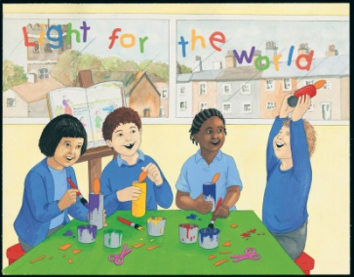
Act of Worship
“CELEBRATING”
EARLY YEARS
Gathering
Together
Children could be seated in a circle

Focus Table: (To be built up during the Liturgy)
Brightly coloured cloth
Bible (open at Luke2:23 - 40)
Number of nightlight candles
Several balloons - Party poppers (streamers)
Plate of small biscuits
Children’s drawings - or projected picture of the “Presentation in the Temple” (e.g. from internet or “God’s Story” 1 – p28-29)

Leader: Welcome to our celebration. We gather In the name of the Father and of the Son and of the Holy Spirit Amen.
As we sing our opening hymn we will see the Bible, part of which tells us all about Jesus - carried in and placed in a position of great importance.
Now let’s sing together “Lighting the Way” - Rejoice 1 (20) or Gathering hymn

Reader: When we have special times in our lives, we often show our happiness by having a special celebration. For example we have special celebrations at Christmas and for birthdays, weddings, baptisms and anniversaries.
Children could show pictures / paintings of these special events

Reader: Often we decorate our rooms and the things around us in different ways for celebrations. We decorate our rooms using bright and shiny colours to show how happy we are and to make people feel welcome. We try to make our rooms special for special celebrations.
Children can place balloons and streamers around the focal point or use pictures from “Church’s Story 2” p25.

Reader: We also usually ask some friends to join us and have some special food to share with them.
A child from each class can bring forward a plate of biscuits (sweets) which they will “share” with another class at the end of the celebration. – remember to check numbers!

Reader: Not so long ago we celebrated the birth of Jesus, and in our “Celebrating” topic we heard of the celebration when his family thanked God for him.
Children can display their pictures – or an illustration of the Presentation in the Temple can be projected. (e.g. from “God’s Story 1” –p28 - 29)

Reader: We are now going to listen to a reading from the Bible which reminds us of some other people - Simeon and Anna - who celebrated when they found that Jesus had been born.

Reader: A reading from the Holy Gospel according to Luke
The Word of God

Glory to you, O Lord
Mary and Joseph took Jesus to the temple.
He was their baby boy and they wanted to thank God for him.
At the temple they met Simeon and Anna. They were both old and had been going to the temple to pray for many years.
They were very happy to see Jesus and thanked God for him.

The Gospel of the Lord
Praise to You Lord Jesus Christ

Reader: When we celebrate some special event with our friends or
Response to The Word
family, we thank them for coming, or thank them for inviting us to join in their happy event. Now let us thank God together for the many things God has given us to celebrate.

The words of the prayer, or response, could be projected.

Reader: The response is, “We thank you, God.”

Reader: Like Simeon and Anna, who celebrated the birth of your son Jesus… Response

Reader: For the celebrations and love we share with our families……… Response

Reader: For the happy times we share with our friends ………. Response

Reader: For the music we enjoy and the songs we sing ……… Response

Reader: For our parish family who celebrate together. …….. Response

Leader: Now think quietly of a celebration which you especially enjoyed. Remember the things that made you feel so happy, and in your heart thank God for that special time….
Going
Forth
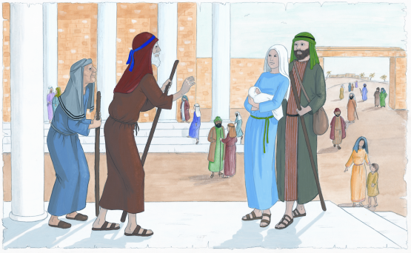
Remember also to share the work we have been doing at home after school today with your family and friends.

Final hymn: “Give me joy in my heart”
(or similar joyous song, for example “This is the day”).

In the name of the Father and of the Son
and of the Holy Spirit Amen.

