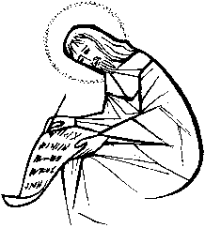
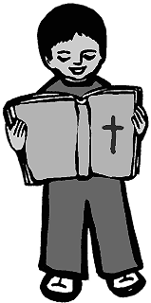
Act of Worship
“BOOKS”
Year 2

Focal Point: Table covered by cloth
Gathering
Together

2 candles
Display of different types of books (spread on floor) chosen earlier by children from each class
Display of religious books set out on table
(Include prayer books, children’s bible, God’s Story,
Church Story, Mass books, etc)
Large (adult) Bible
Stand (support) for Bible

Leader: We have come together to celebrate and pray In the name of the Father and of the Son and of the Holy Spirit. Amen. Let us rejoice as we sing.

Opening Hymn: “Picture Books” - Rejoice 1 (17) or a Gathering hymn

Leader: Welcome to our celebration. The theme of our celebration today is Books. There are lots of books displayed here today: stories, poems, nursery rhymes. Books that have been chosen by you, as your special, or favourite books.
Then on the table we have more books. These are special books too, because they are books with very important information inside. (Highlight themes of stories of God’s messages for us, stories about Jesus, prayers to God, etc.)
The most important book of all is going to be carried forward for us.
(Quiet music plays, while a group of children process to the table. The first two carefully carry lighted candles, while a third carries the large Bible).
This is our Bible, God’s special book. (Hold up Bible for all to see.) This great book is in two parts - the first part is all about God and his dealings with people, and the second part is about the life of Jesus on earth, and his message of God’s love – which He wants us to share with everyone.

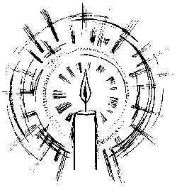
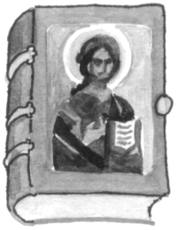

Reader: The Bible has been left open at a very important story – which we are going to listen to now. This tells us of Jesus’ baptism. Before Jesus started his ministry of teaching and healing he asked John the Baptist, his cousin, to baptise him.
Let us welcome God’s Word with joy.
All sing:”Alleluia, Alleluia” while the Bible is placed on its stand, opened at Matthew 3:13-17. The candles are placed on either side of it.

A reading from the Gospel of Saint Matthew, (remind the children to make the sign of the cross on their heads – to know and understand God’s Word; lips – to speak God’s Word and heart – to love God’s Word)

The Word
Of God
All: Glory to you, O Lord
Reader: At that time Jesus arrived from Galilee and came to John at the Jordan to be baptised by him. But John tried to make him change his mind. “I ought to be baptised by you,” John said, “and yet you have come to me!” But Jesus answered him, “Let it be so for now. For in this way we shall do all that God requires.” So John agreed. As soon as Jesus was baptised, he came up out of the water. Then heaven was opened to him, and he saw the Spirit of God coming down like a dove and lighting on him. Then a voice said from heaven, “This is my own dear Son, with whom I am pleased.”

Leader: The Gospel of the Lord.
All: Praise to you, Lord Jesus Christ.

Leader: Let us reflect quietly for a few moments on this story, while looking at this painting of the Baptism of Christ. Let us remember some of the many blessings, which God has given to us– especially that of Jesus, his own dear Son.
Response to
the Word.
Silent pause (image of the Baptism on IWB)

Leader: Now let us join together in prayer to thank God, and Jesus, and his message of love for us. (Could be displayed on screen)

Reader: For all these books which we enjoy so much.
All: We thank you, God.
Reader: For the love you have shown us.
All: We thank you, God.
Reader: For the gift of your own Son, Jesus.
All: We thank you, God.
Reader: For Jesus’ message of love and kindness to all.
All: We thank you, God.
Reader: For the Bible, which tells us of all these things.
All: We thank you, God.
Going
Forth

Leader: To show that we know and understand God’s message of love and
kindness, which is written in the Bible, let us join hands as friends as we sing our final hymn.

All sing: “An Alleluia Song” Rejoice 1 – (15) or God’s Greatest Gift, Bernadette Farrell

In the name of the Father and of the Son and of the Holy Spirit Amen.

After the final hymn is sung, the procession of children carrying the candles and Bible leaves the room to quiet music.

